Hellman Foundation
COLLABORATIVE CHANGE INITIATIVE
This Request for Information (RFI) is for LAUNCH Grants
Deadline for Submission: March 16, 2022

The Hellman Foundation is thrilled to announce the launch of our 2022 round of Collaborative Change Initiative funding for ambitious cross-sector collaborations. LAUNCH grants will be made to collaborations in San Francisco and/or Alameda County.
The Hellman Foundation invites interested collaborations who meet our qualifications and priorities to respond to this Request for Information (RFI) for LAUNCH funding. We will use the RFI responses to determine if there is a match with our priorities and then invite a few candidates to submit a detailed proposal. Detailed information for LAUNCH grant opportunities is below, including eligibility requirements, size and structure of the grants, and criteria for using grant funds. The RFI application is on page 5 of this document.
WEBINAR for INTERESTED APPLICANTS
On February 17, 2022, a webinar will be provided to provide more information to potential applicants about the Hellman Collaborative Change Initiative and the LAUNCH & GROWTH tracks. There will be time available during the webinar to ask questions about the Initiative and Request for Information application.
Supporting Collaborative Change: 2022 LAUNCH Grants
Informed by research and current collaborative grantee partners' experiences, we know that successful collaborations that achieve broad impact proceed through phases, including planning and coordination, pilot testing, building momentum, initial scaling, and institutionalization, as seen below in the "Five Phases of Collaboration":
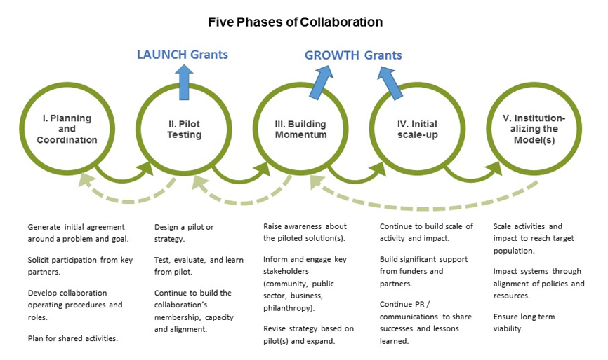
Through the Collaborative Change Initiative, the Hellman Foundation is committed to supporting cross-sector collaborations at two key developmental phases:
1. LAUNCH Grants support early-stage collaborations to:
- Pilot new solutions that have the potential to be scaled for broad impact
- Build stakeholder support from diverse sectors and community members with lived experience to effectively implement and learn from the tested solution(s)
- Build the internal strength of the collaboration to carry out their work effectively and to generate stakeholder support towards eventual goals of scale and long-term sustainability
Collaborations should be in Phase II of the Five Phases of Collaboration (illustrated above) and meet other requirements listed below, to apply for this LAUNCH funding.

2. GROWTH Grants invest in proven impactful collaborations to grow momentum and support scaling solutions and making systems changes. Collaborations should be in Phases III and IV of the Five Phases of Collaboration (illustrated above) to apply for this GROWTH funding. Please see the information and the separate Request for Information on our website.

The Hellman Foundation will provide up to 4 grant awards in LAUNCH and GROWTH tracks in this grant period beginning in January 2023.
2022 LAUNCH GRANTS
Size and Structure of Grants
Funding Amount
Collaborations can request up to $450,000 total over a three-year grant period starting January 1, 2023. At the end of this initial three-year grant period, collaborations may be eligible to apply for GROWTH funding.

Use of Funds
LAUNCH Grants are a flexible funding source intended to meet the dynamic needs of early-stage collaborations that build their communal table, community engagement, and promising solutions with the goal of citywide or countywide change. Grant funds may be used to:
- Support core operations of the collaboration, including staffing, consultants, data collection, meeting, and other backbone costs
- Cover costs related to the implementation of the proposed pilot, including backbone staffing, program activities, and evaluation costs
- Support activities that build the strength and effectiveness of the collaboration
The work of the collaboration should:
- Address a current equity need in San Francisco, a city in Alameda County (e.g., Oakland, Hayward, Berkeley) or the county as a whole. The Hellman Foundation prioritizes collaborations tackling disparities in health, education, and opportunity, but we are open to compelling collaborative projects addressing other disparities in individual outcomes and community wellbeing.
- Have well-articulated goals and strategy(ies) that:
  - Have a clear potential for citywide or countywide impact through scaling of activities and/or systems change
  - Were informed by intentional & deep community engagement and rigorous data
  - Were developed through a collaborative process and outline a set of activities that involves the members of the cross-sector collaboration
  - Include providing direct services to the target population(s)
  - Have the potential for sustainability over time
- Be ready to implement and evaluate promising solutions through a pilot you seek support (see Phase II in our Five Phases of Collaboration diagram).

We understand that COVID has impacted opportunities for people and organizations to convene and collaborate compared to previous years. We believe that uplifting cross sector collaborative solutions are critical to the recovery and rebuilding of the most impacted Bay Area communities. Please feel free to highlight in your responses the strengths of your collaboration and touch on specific challenges your collaboration has faced within this context.

Capacity Building Support
Collaborations that receive LAUNCH grants also participate in customized capacity-building activities to build their collaborative strength and effectiveness. The collaboration's leadership will partner with the Hellman Foundation team to complete a capacity assessment, develop a capacity-building plan, and identify customized resources. This tailored support could include cohort trainings and other capacity-building support: collaborative governance, metric development, fund development, leadership coaching, and communications. Please find more information about the Initiative’s approach to capacity building here.

We encourage you to visit the Hellman Foundation website to read about the current LAUNCH grantee partners to get a sense of the type of collaborations we have supported in the past, including Alameda County Families United CARE and Expecting Justice.

ELIGIBILITY REQUIREMENTS
LAUNCH Collaborations should:
- Be an existing and active cross-sector collaboration in San Francisco or Alameda County that includes a total of at least four partner institutions and at least six individual members, including representatives of the community where program activities occur. The Foundation seeks collaborations that are collectively led by its members and not a single organization or leader.
  - Applicants for LAUNCH funding must have a proven track record of working together that pre-dates this proposal.
- Include lead partners from the non-profit and the public sectors (e.g., local/state government, public school districts, public hospitals, and universities); the strongest candidates for this Initiative will represent a broad diversity of organizations from many sectors including business, higher education, tech, faith-based, or others.
- Intentionally & meaningfully center community members with lived experience who are active in the collaboration's table, engage in decision-making, and participate within the targeted community.
- Have in-kind commitments and/or financial resources to support the collaboration's effort
- Effectively manage core collaborative functions, such as guiding strategy and vision, facilitating meetings, coordinating activities or work plans, and monitoring progress
  - Hellman funding can be utilized for backbone staffing to support these functions
- Be willing and able to participate in a grant initiative that prioritizes accountability, transparency, capacity building, and learning
- Be in Phase II of the Five Phases of Collaboration (illustrated above)
Please Note: Based on experience, we anticipate a high volume of responses to this RFI, as there are so many promising collaborative efforts in the Bay Area. Please carefully review the criteria to confirm fit and eligibility before submitting your information to the Hellman Foundation.

WEBINAR FOR INTERESTED APPLICANTS – February 17, 2022
To register, click here.
A webinar will be provided to share more information about the Hellman Collaborative Change Initiative and the LAUNCH and GROWTH tracks. There will be time available during the webinar to ask questions you have about the Request for Information. Head to www.hellmanfoundation.org to register or watch the recording that will be available on the website, no later than February 22, 2022
QUESTIONS?
For additional questions about eligibility or the process, we highly encourage you to review the FAQ page on our website. Please feel free to contact Dorian Luey, Associate Director, at apply@hellmanfoundation.org.

2022 LAUNCH GRANT APPLICATION
Please review and complete Sections 1-3. Submission instructions are at the end of the application.

SECTION 1: COLLABORATION OVERVIEW
Please provide the following information.
- Name of collaboration:
- Collaboration contact name, phone number and email address:
- Year collaboration came together:
- Issue area addressed by collaboration:
☐ Health equity
☐ Education equity
☐ Equitable opportunity
Collaboration's intended geographic reach with this grant (check all that apply):
☐ Citywide: San Francisco
☐ Citywide: Oakland
☐ Citywide: Another Alameda County city(ies), please specify:
☐ Countywide: Alameda

SECTION 2: NARRATIVE
Please respond to the following questions in a narrative that does not exceed 4 pages total.
The Collaboration
- Purpose
- In one sentence, describe the goal your collaboration is trying to achieve, in terms of a change that will happen at citywide or countywide scale. Express your goal in measurable terms if possible and include a time frame.
EXAMPLES: Over the next XX years, ABC Collaboration will transform access to prenatal nutrition, ensuring that XX% of all pregnant mothers have consistent access to healthy food.
By 20XX, XX% of low-income preschoolers in Oakland will participate in high quality early literacy and math programs, leading to a significant increase in kindergarten readiness.
- Briefly describe demographics of the target population for this collaboration's work (Indicate specific communities e.g., Mission in SF, Bay View Hunter's Point, Fruitvale in Oakland, West Oakland, South Berkeley, etc.)
- Leadership and Membership
  - What are the 2 – 3 most significant achievements of the collaboration to date?
  - Name the organizations (and key individuals within those organizations) that serve in leadership roles for the collaboration. Briefly describe the key functions that they each fill within the collaboration.
- Why are the members of this collaboration the right people to take on this project and issue?
- How are community members engaged in the collaboration's table?
Your Approach
- Strategy
- What data and experience demonstrate the need for your collaboration's work in San Francisco or Alameda County?
- What are the key elements of your strategy? How was the strategy developed?
- Pilot Proposal
- What solution(s) / activities will you test with the proposed pilot(s)?
- How will you implement and evaluate the pilot(s)?

Collaboration Resources
- What financial and /or in-kind resources currently support your collaboration's core operations and work in the community?
- Describe how you would utilize Hellman LAUNCH Grant funding, including:
- What major costs would you support with grant funding? A detailed budget is not required for the RFI.
- What grant amount would you request, and for what duration (applicants will be invited to request up to $150,000/year for up to 3 years)?

SECTION 3: ATTACHMENTS
Please list your collaboration's key members, using the following format (adding additional rows as needed)
 | Name | Title | Organization | Role | Sector (indicate one)*:  1. Community  2. Public sector  3. Non-profit  4. Business  5. Other (Please state)
1 | Example:  Jae Sugawara | Example:  Executive Director | Example:  CommCares | Example:  Fiscal manager | Example:  Non-profit
2
3
4
5
*1. Community – member/representative of the community that is leading or benefitting from the collaboration’s work
2. Public sector - e.g., local/state governments, public school districts, public hospitals, and universities
3. Non-profit – charitable, 501c3 organizations
4. Business – for-profit, corporate entities
5. Other (Please state) - entities that are not described above

INSTRUCTIONS FOR SUBMISSION
Please compile your responses and send an email with attachments to: apply@hellmanfoundation.org

Please use the following file names and formats for your submission:

- Combine Sections 1 & 2 as a single Word doc and name the file: "[Your Collaboration’s Name] _2022 HCCI LAUNCH RFI"
- Send attachments as individuals documents in Word and/or PDF

The Hellman Foundation team will confirm receipt of your submission.

LAUNCH RFI submission deadline: March 16, 2022 at 5:00 p.m. PT
Thank you for your commitment to creating a more equitable, healthier, and stronger Bay Area. We look forward to learning more about the work you do.

