HELLMAN FOUNDATION
COLLABORATIVE CHANGE INITIATIVE
This Request for Information (RFI) is for GROWTH Grants
Deadline for Submission: March 16, 2022

The Hellman Foundation is thrilled to announce the launch of our 2022 round of Collaborative Change Initiative funding for ambitious cross-sector collaborations. GROWTH grants will be made to collaborations in San Francisco and/or Alameda County.
The Hellman Foundation invites interested collaborations who meet our qualifications and priorities to respond to this Request for Information (RFI) for GROWTH funding. We will use the RFI responses to determine if there is a match with our priorities and then invite a few candidates to submit a detailed proposal. Detailed information for GROWTH grant opportunities is below, including eligibility requirements, size and structure of the grants, and criteria for using grant funds. The RFI application is on page 5 of this document.
WEBINAR for INTERESTED APPLICANTS
On February 17, 2022, a webinar will be provided to provide more information to potential applicants about the Hellman Collaborative Change Initiative and the LAUNCH & GROWTH tracks. There will be time available during the webinar to ask questions about the Initiative and Request for Information application.
Supporting Collaborative Change: 2022 GROWTH Grants
Informed by research and current collaborative grantee partners' experiences, we know that successful collaborations that achieve broad impact proceed through phases, including planning and coordination, pilot testing, building momentum, initial scaling, and institutionalization, as seen below in the "Five Phases of Collaboration": 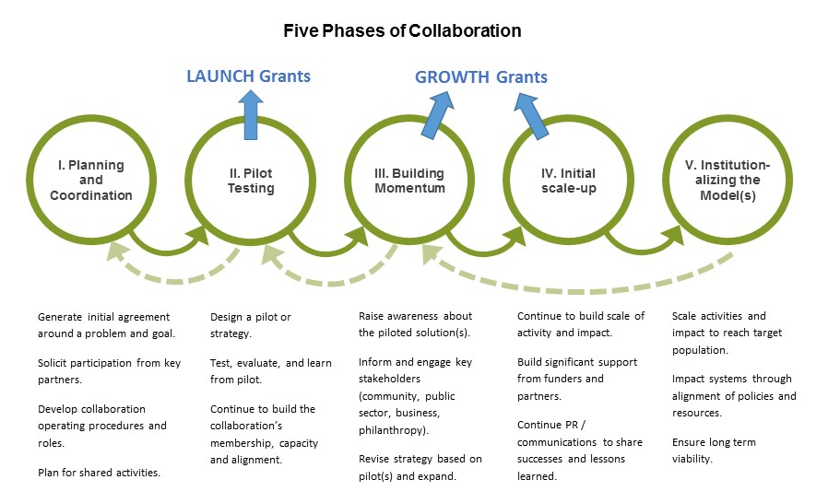
Through the Collaborative Change Initiative, the Hellman Foundation is committed to supporting cross-sector collaborations at two key developmental phases:
- GROWTH Grants support mid-stage collaborations to:
- Scale proven & impactful solutions and implement systems-level change that have the potential for broad city and/or county wide impact
- Strengthen their cross-sector collaborations to enable scaled impact and long-term sustainability
- Build engagement and support from diverse sectors needed to reach ambitious goals
Collaborations should be in Phases III & IV of the Five Phases of Collaboration (illustrated above), and meet other requirements listed below, to apply for this GROWTH funding.

- LAUNCH Grants support early-stage collaborations to launch new strategies by pilot testing a promising solution or set of solutions. Collaborations that are a good fit for LAUNCH Grants are those currently in Phase II of the Five Phases of Collaboration illustrated above. Please see the information and the separate Request for Information on our website.

The Hellman Foundation will provide up to 4 grant awards total in LAUNCH and GROWTH tracks for this grant period beginning in January 2023.

2022 GROWTH GRANTS
Size and Structure of Grants

Funding Amount
Collaborations can request up to $750,000 total over a five-year grant period. The grant period starts January 1, 2023 and ends December 31, 2027.
Use of Funds
GROWTH Grants are a flexible funding source intended to meet the dynamic needs of mid-stage collaborations to scale solutions and create systems change. Grant funds may be used to:
- Fund core and backbone operations of the collaboration, including staffing, consultants, meetings, data collection, evaluation, and other costs.
- Cover costs of direct services provided by the collaboration, including staffing and other direct expenses.
- Support activities to build the strength and effectiveness of the collaboration’s infrastructure and processes.
- Build financial, political, and/or public support for the collaboration, its partners, and the issue.

The work of the collaboration should:
- Have well-articulated goals and strategy(ies) that:
  - Have a clear potential for citywide or countywide impact through scaling of activities and/or systems change
  - Were informed by intentional & deep community engagement and rigorous data
  - Were developed through a collaborative process and outline a set of activities that involves the members of the cross-sector collaboration
  - Include providing direct services to the target population(s)
  - Have the potential for sustainability over time
- Be in the Building Momentum or Initial Scale Up Phase (see Phases III and IV in our Five Phases of Collaboration diagram above), ready to build momentum to scale proven solutions.
We understand that COVID has impacted opportunities for people and organizations to convene and collaborate compared to previous years. We believe that uplifting cross sector collaborative solutions are critical to the recovery and rebuilding of the most impacted Bay Area communities. Please feel free to highlight in your responses the strengths of your collaboration and touch on specific challenges your collaboration has faced within this context.
Capacity Building Support
Collaborations that receive GROWTH awards will also participate in customized capacity building activities to build their collaborative strength and effectiveness. The collaboration’s leadership will partner with the Hellman Foundation team to complete a capacity assessment, develop a capacity building plan, and identify customized resources. This tailored support could include cohort trainings and other capacity building support: collaborative governance, metric development, fund development, leadership coaching and/or strategic communications. Please find more information about the Initiative’s approach to capacity building here.
We encourage you to visit the Hellman Foundation website to read about the current GROWTH grantee partners to get a sense of the type of collaborations we have supported in the past, including Food As Medicine, Oakland Starting Smart & Strong, and End Hep C SF.
ELIGIBILITY REQUIREMENTS
GROWTH Collaborations should:
- Be an existing cross-sector collaboration that includes a total of at least 5 partner institutions/organizations and at least 8 individual members including representatives of the community where program activities occur. The Foundation seeks collaborations that are led by its members and not a single organization or leader.
  - Applicants for GROWTH funding must have a proven track record of working together that pre-dates this proposal.
- Include lead partners from the non-profit and the public sectors (e.g., local/state government, public school districts, public hospitals, and universities); the strongest candidates for this Initiative will represent a broad diversity of organizations from many sectors including business, higher education, tech, faith-based, or others.
- Intentionally & meaningfully center community members with lived experience who are active in the collaboration’s table, engage in decision-making, and participate within the targeted community.
- Have a track record of working together as a cross-sector collaboration that includes creating a shared vision and strategy, testing solutions, providing direct services, and learning from experience.
- Effectively manage core collaborative functions, such as facilitating meetings, coordinating activities or workplan, maintaining communication and monitoring progress.
  - Have or plan to utilize Hellman funding to support at least a .5FTE (20 hours/week) to staff the collaboration.
- Be active in implementing solutions with the potential for citywide or countywide scale in San Francisco, a city in Alameda County, or across Alameda County.
- Have committed in-kind resources and financial support for the collaboration.
- Be willing and able to participate in a grant initiative that prioritizes accountability, transparency, capacity building, and learning.
- Be in the Building Momentum or Initial Scale Up Phase (Phases III and IV)
Please Note: Based on experience, we anticipate a high volume of responses to this RFI, as there are so many promising collaborative efforts in the Bay Area. Please carefully review the criteria to confirm fit and eligibility before submitting your information to the Hellman Foundation.
WEBINAR FOR INTERESTED APPLICANTS – February 17, 2022
To register, click here. A webinar will be provided to share more information about the Hellman Collaborative Change Initiative and the LAUNCH and GROWTH tracks. There will be time available during the webinar to ask questions you have about the Request for Information. Head to www.hellmanfoundation.org to register or watch the recording that will be available on the website, no later than February 22, 2022.

QUESTIONS?
For additional questions about eligibility or the process, we highly encourage you to review the FAQ page on our website. Please feel free to contact Dorian Luey, Associate Director, at info@hellmanfoundation.org.

2022 GROWTH GRANT APPLICATION
Please review and complete Sections 1-2. Submission instructions are at the end of the application.

SECTION 1: COLLABORATION OVERVIEW
Please provide the following information.
- Name of collaboration:
- Collaboration contact name, phone number and email address:
- Year collaboration came together:
- Issue area addressed by collaboration:
☐ Health equity
☐ Education equity
☐ Equitable opportunity
Collaboration’s intended geographic reach with this grant: (check all that apply):
☐ Citywide: San Francisco
☐ Citywide: Oakland
☐ Citywide: Another Alameda County city, please specify:
☐ Countywide: Alameda
☐ Other (Please state):

SECTION 2: NARRATIVE
Please respond to the following questions in a narrative that does not exceed 4 pages total.
The Collaboration
- In one sentence, describe the goal your collaboration is trying to achieve, in terms of a change that will happen at citywide or countywide scale. Express your goal in measurable terms if possible and include a time frame:
EXAMPLES: Over the next XX years, ABC Collaboration will transform access to prenatal nutrition, ensuring that XX% of all pregnant mothers have consistent access to healthy food.
By 20XX, XX% of low-income preschoolers in Oakland will participate in high quality early literacy and math programs, leading to a significant increase in kindergarten readiness.
- In one paragraph, describe demographics of the target population for this collaboration’s work:
- In section 3, you will be asked to name the organizations and individuals that serve in key roles for the collaboration. Why are the members of this collaboration the right people to take on this project and issue?
- How are community members engaged in the collaboration's table?

Your Approach
- Strategy & Impact
- What data and experience demonstrate the need for your collaboration’s work?
- What are the key elements of your strategy?
- What is the current scale of the solutions your collaboration provides? What is the intended scale over time? How are your solutions key to accomplishing the intended change you seek to make?
- What challenges, constraints and opportunities to achieve your ambitious goals can be addressed with this funding?

Collaboration Resources
- What financial and /or in-kind resources currently support your core operations and work in the community?
- What grant amount would you request (applicants will be invited to request up to $750,000 total over 5 years)?
- What major costs would you support with grant funding? Please provide a list with some narrative details. A detailed budget is not required for this RFI.
  - Please note that you must have current funding or plan to utilize Hellman funding to support at least a .5FTE to staff the collaboration

SECTION 3: ATTACHMENTS
Please list your collaboration's key members, using the following format (adding additional rows as needed)
 | Name | Title | Organization | Role | Sector (indicate one)*:  1. Community  2. Public sector  3. Non-profit  4. Business  5. Other (Please state) | MOU in place with this partner?  Yes/No
1 | Jae Sugawara | Example:  Executive Director | Example:  CommCares | Example:  Fiscal manager | Example:  Non-profit | Example:  Yes
2
*1. Community – member/representative of the community that is leading or benefitting from the collaboration’s work
2. Public sector - e.g., local/state governments, public school districts, public hospitals, and universities
3. Non-profit – charitable, 501c3 organizations
4. Business – for-profit, corporate entities
5. Other (Please state) - entities that are not described above

INSTRUCTIONS FOR SUBMISSION
Please compile your responses and send as an email with one attachment to: apply@hellmanfoundation.org

Please use the following file names and formats for your submission:

- Combine Sections 1 & 2 into a single Word doc, named "[Your Collaboration’s Name] _2022 HCCI GROWTH RFI"
- Send attachments as individuals documents in Word and/or PDF

The Hellman Foundation team will confirm receipt of your submission.

GROWTH RFI submission deadline: March 16, 2022 at 5:00 p.m. PT
Thank you for your commitment to creating a more equitable, healthier, and stronger Bay Area. We look forward to learning more about the work you do.

